**Hotel Booking Database using MongoDB Codes**

**First created 4 databases named:**

* *user*
* *hotel*
* *room_status*
* *booking_details*

1. **Added 5 Users' Data into the Database**

*(Added Name,Address,phone no,gender,email*,field names*)*

*(using InsertOne and InsertMany Commands)*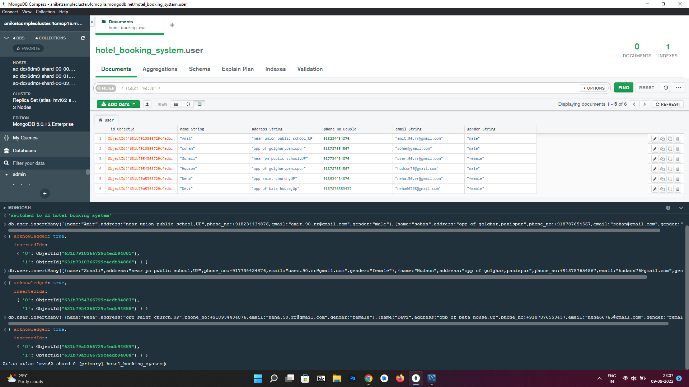

After this,

1. **Added 5 Hotels' Data into the Database**

*(Added Hotel Name,Address,city,phone no,city,no of room,facilities* field names*)*

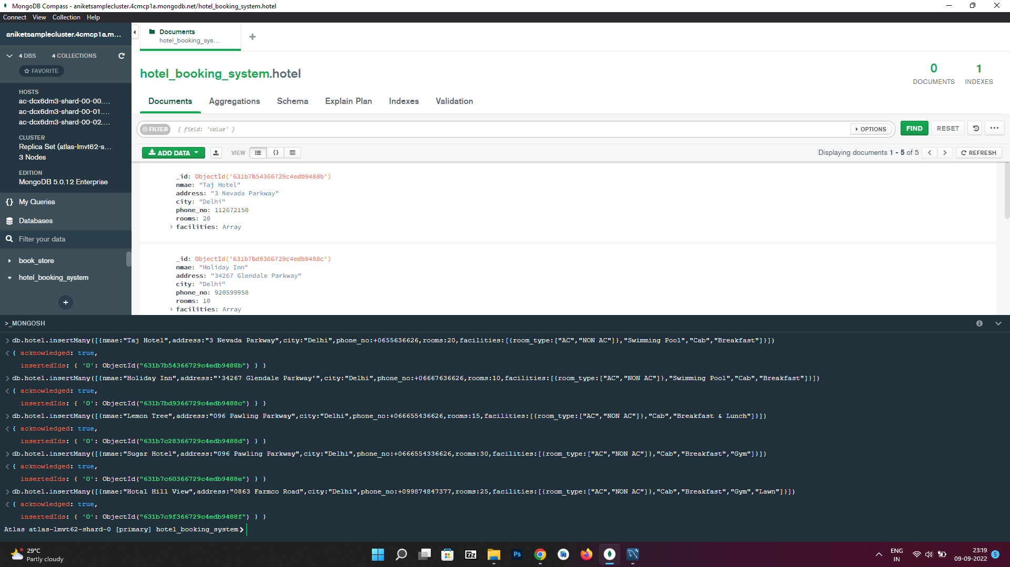

*(using InsertOne and InsertMany Commands)*

1. **All data are updated on the server**

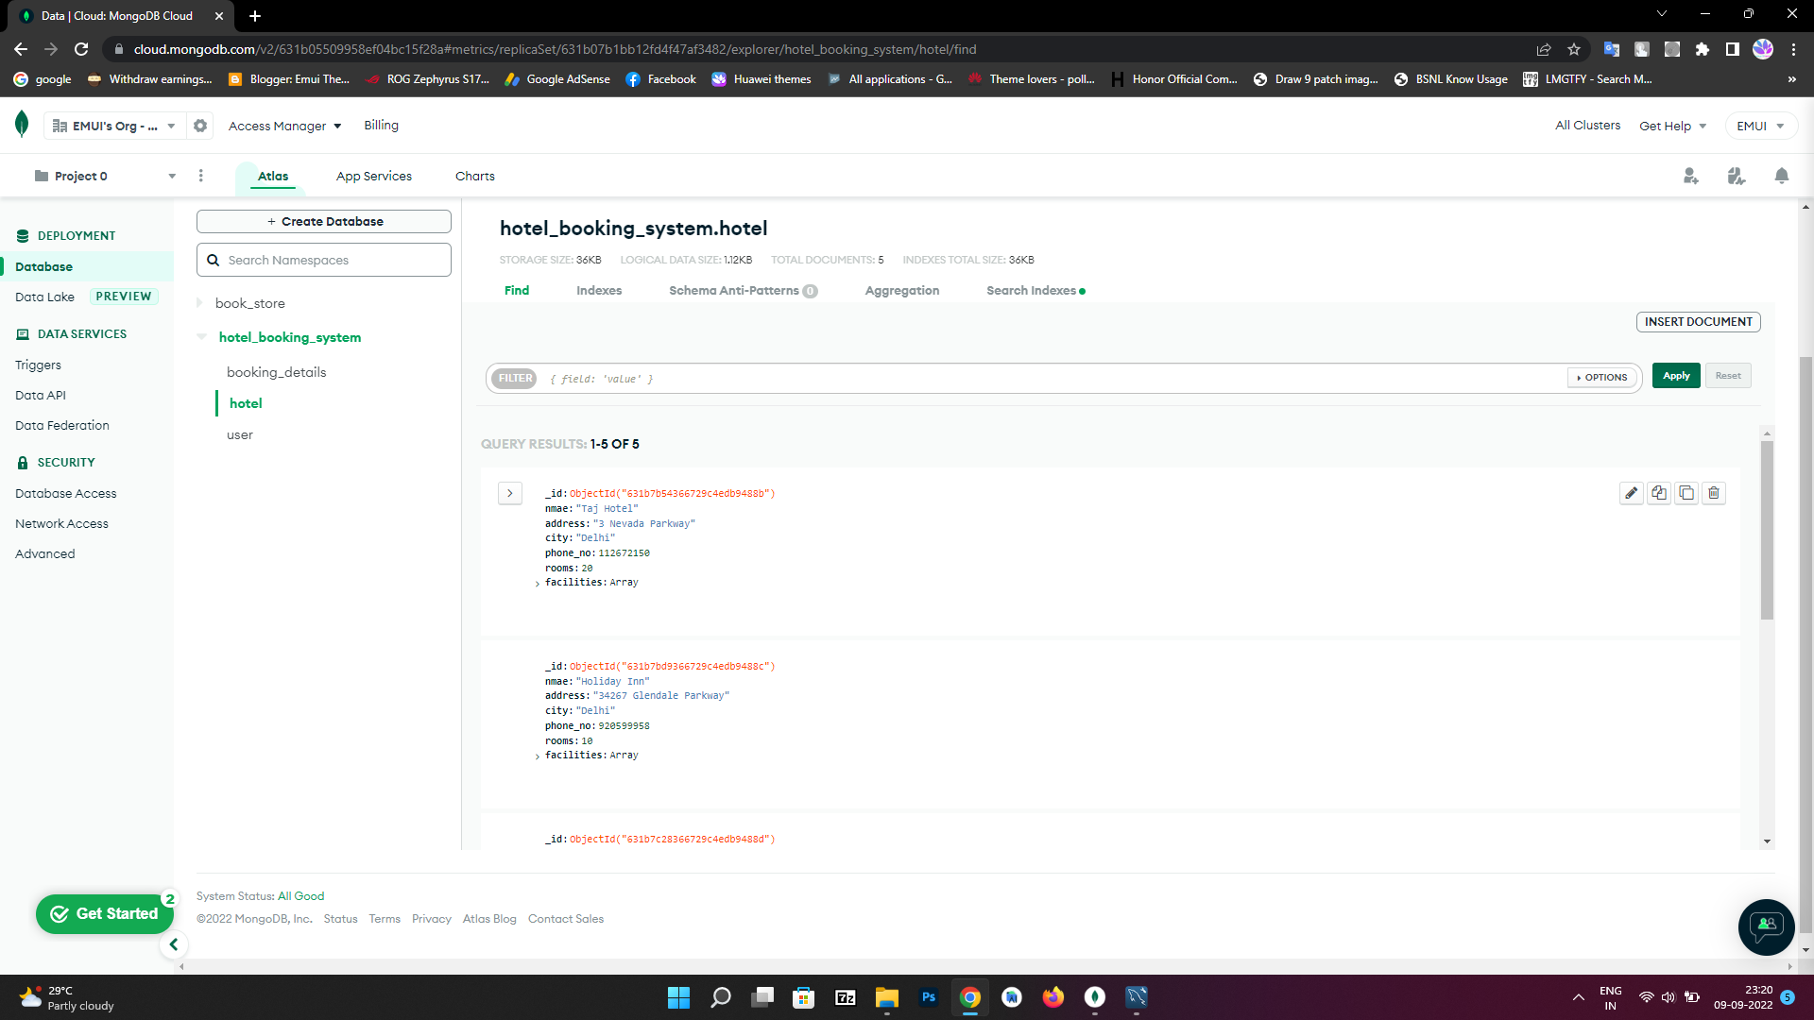

1. **Searching user using AND operator to filter duplicate Name user**

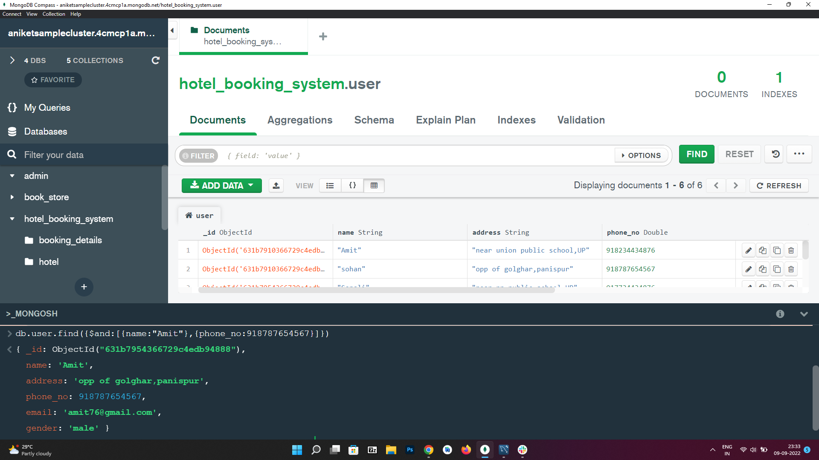

*db.user.find({$and:[{name:”Amit”},{phone_no:918787654567}]})*

1. **Searching Available Room Hotel Name**

*[Using $all Operator]*

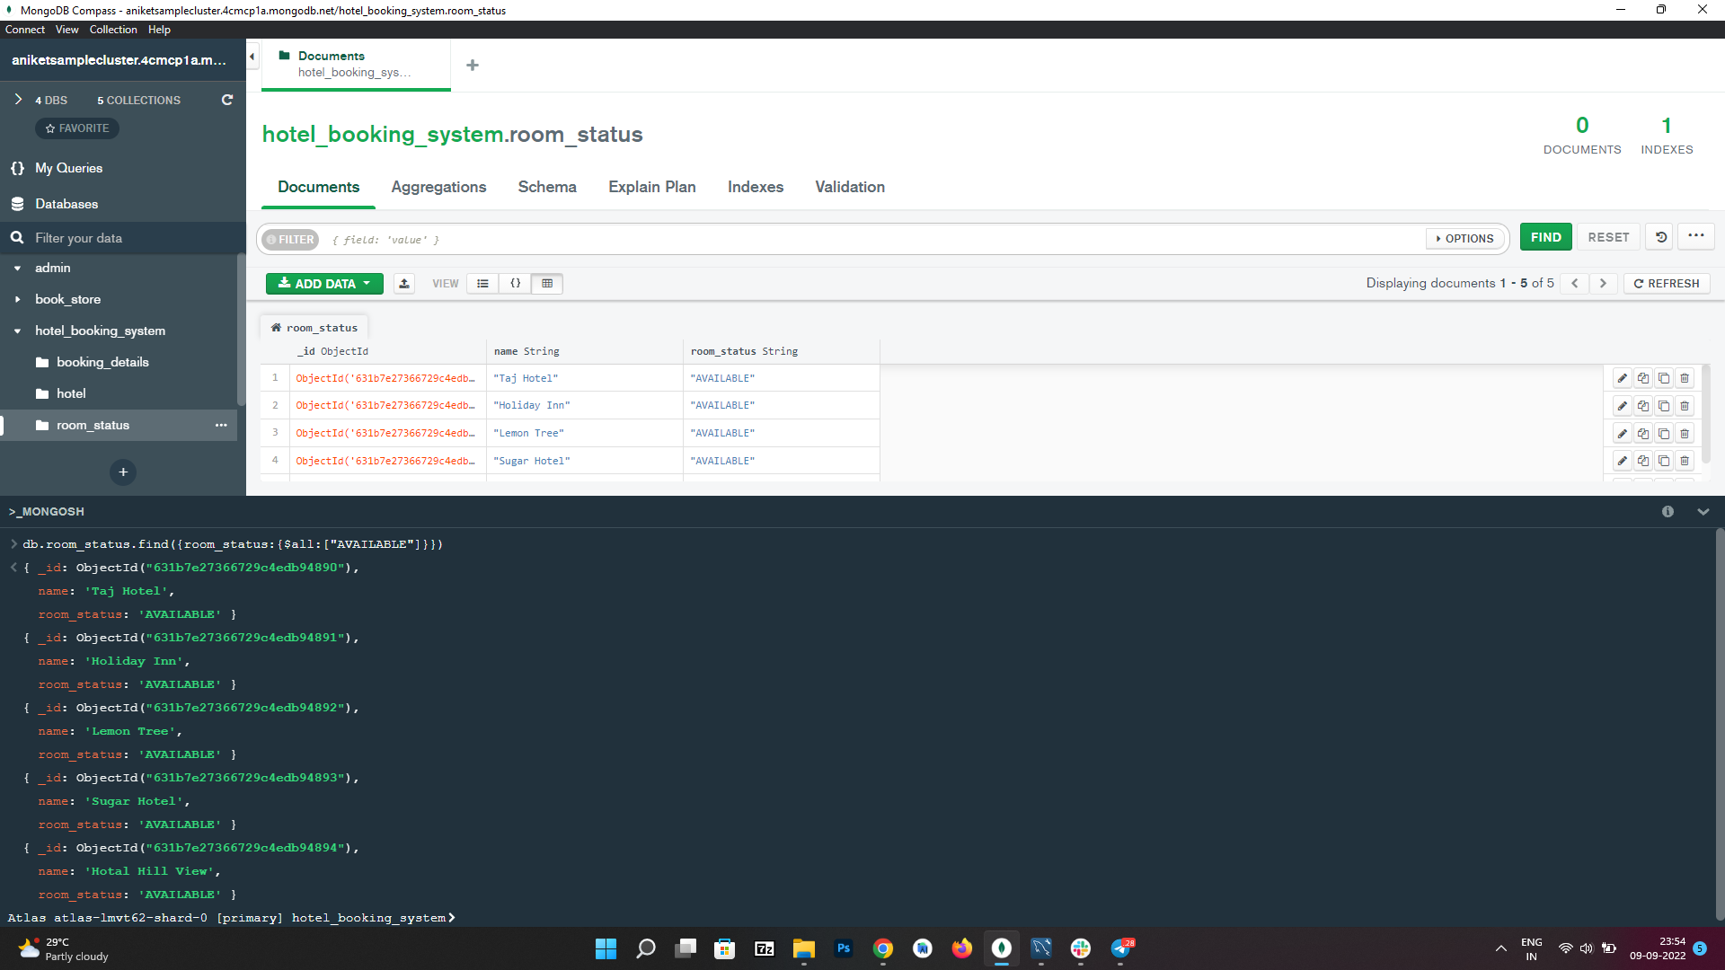

db.room_status.find({room_status:{$all:[“AVAILABLE”]}})

1. **Booking Selected Hotel Room**

*(using Insert Query)*

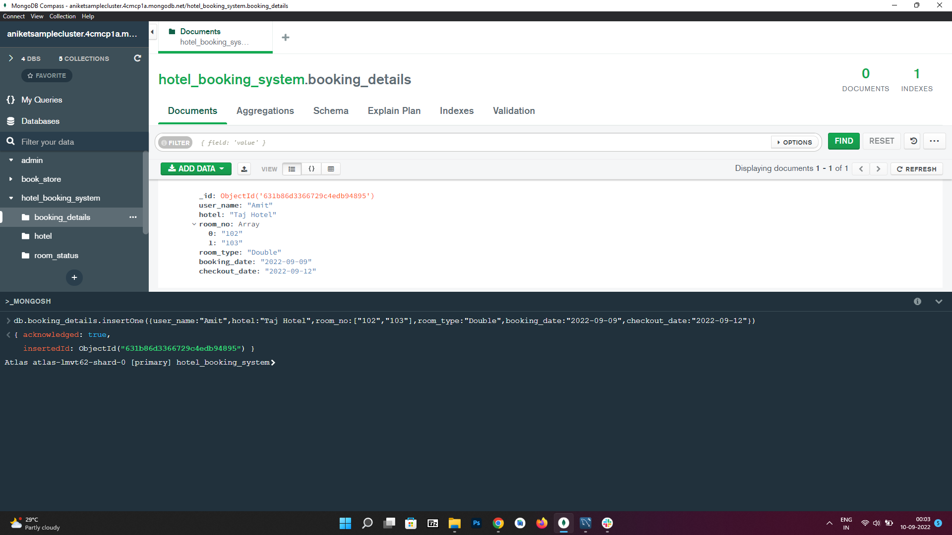

*db.booking_details.insertOne({user_name:”Amit”,hotel:”Taj Hotel”,room_no:[“102”,”103”],room_type:”Double”,booking_date:”2022-09-09”,checkout_date:”2022-09-12”})*

1. **Updating Previous Available Room no**

*(using Update Query)*

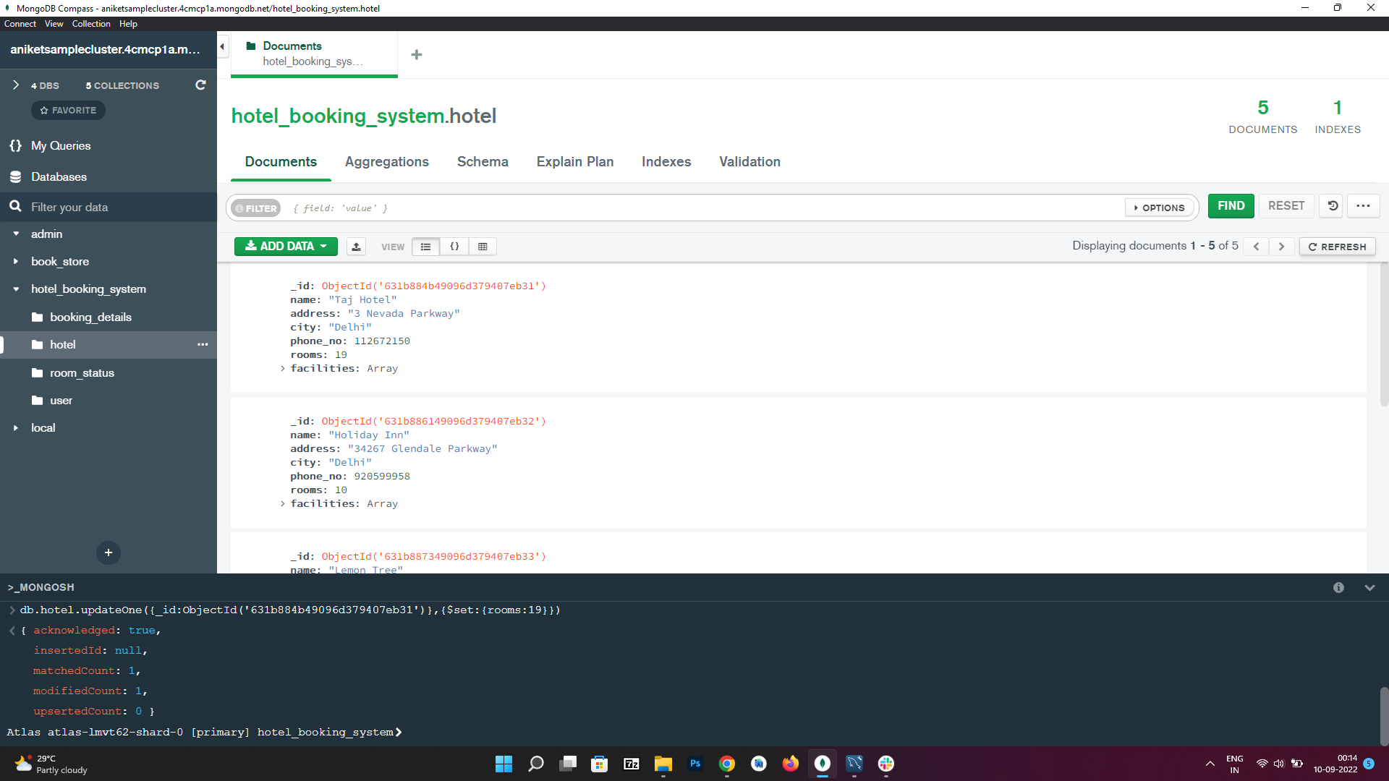

*db.hotel.updateOne({_id:ObjectId(‘631b884b49096d379407eb31‘)},{$set:{rooms:19}})*

1. **Deleting Booking Record After Checkout**

*(using Delete Query)*

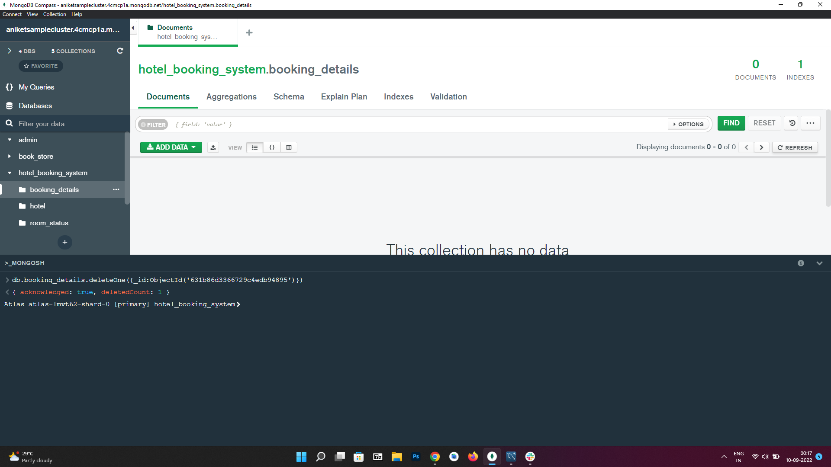

*db.booking_details.deleteOne({_id:ObjectId(‘631b86d3366729c4edb94895’)})*